Chairman C. Ilayappan

Mr. S. Elayappan
Chairman

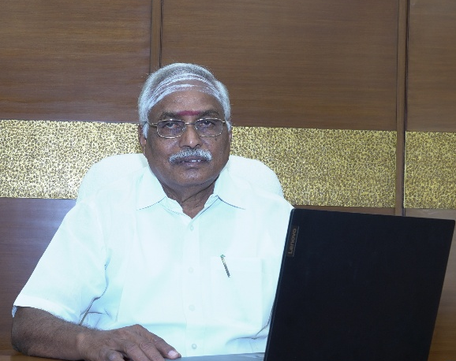

"Bharathiyar Arts and Science College for Women (Autonomous) guided by the noble belief that 'if one woman is educated, an entire family is educated, and an entire generation advances.' Our primary objective is to ensure that quality higher education is accessible to female students from rural and economically needy backgrounds.

In the future, our college will shine not only as an institution of academic excellence but also as a pioneer in all fields, including Research, Technology, Employment, And Social Responsibility. Our students are empowering themselves to develop not only textbook knowledge, but also Self-Confidence, Leadership Qualities, Technical Skills, Creativity, And Social Consciousness. Accordingly, modern educational methodologies, skill development programs, industry-oriented training, and placement guidance are continuously being provided.
Furthermore, there is absolutely no doubt that our college is evolving into a center of higher education that emphasizes research and innovative thinking. Our professors and students are collaboratively creating new knowledge and undertaking research that addresses the needs of society. Through education, our students are becoming self-reliant, economically independent, and socially responsible. Our college continues to provide every student with the confidence and the opportunities to fulfill Mahakavi Bharathiyar's dream.

Our future goal is to build academic and research collaborations with national and international educational institutions, opening up global opportunities for our students.

The Sri Sakthi Educational Trust provides scholarships and the necessary support to those who are economically needy students so they can pursue higher education. We remain resolute in our principle that 'financial constraints should never be a barrier to any student's educational dreams.

“By imparting diverse education,
We must uplift this world.”

To bring this profound quote by Bharathiyar to reality, and driven by the noble ideal of 'eradicating illiteracy,' our ultimate goal of our Arts and Science College will stand as a beacon of excellence."

Mr. S. Elayappan
Chairman


Dr. A. K. Ramasamy
Secretary

Secretary Dr. A.K. Ramasamy
"Our goal is not merely for our students to obtain degrees. They must evolve into highly Employable Professionals, Entrepreneurs, Researchers, Administrators, and Community Leaders.
The future journey of Bharathiyar Arts and Science College for Women (Autonomous) is dedicated to molding a new generation of women who excel in knowledge and capability, inspired by Mahakavi Bharathiyar's noble ideal of empowered womanhood: 'An upright posture and a steadfast gaze.' Every student of our college must embark on her life's journey with the unwavering conviction: 'I can, and I will achieve; I will be of service to my society and my nation.' This is our dream, our vision, and our future goal. Every student who graduates from our college must move ahead believing that her education will uplift not just her own life, but her family and her society as well. Rising through knowledge, excelling through skills, and conquering through self-confidence, my future ambition is for our college to stand as a stellar symbol of excellence for society.

“The learned are honored wherever they go.”
“The presence of the learned brings joy to all.”

True to these wise saying, the wealth of education is the sole force that bestows true courage and independence upon a woman. In that spirit, my ultimate future vision is for our college to shine as a premier educational and research institution, empowering all our students to compete on a global scale and emerge victorious.

Dr. A. K. Ramasamy
Secretary

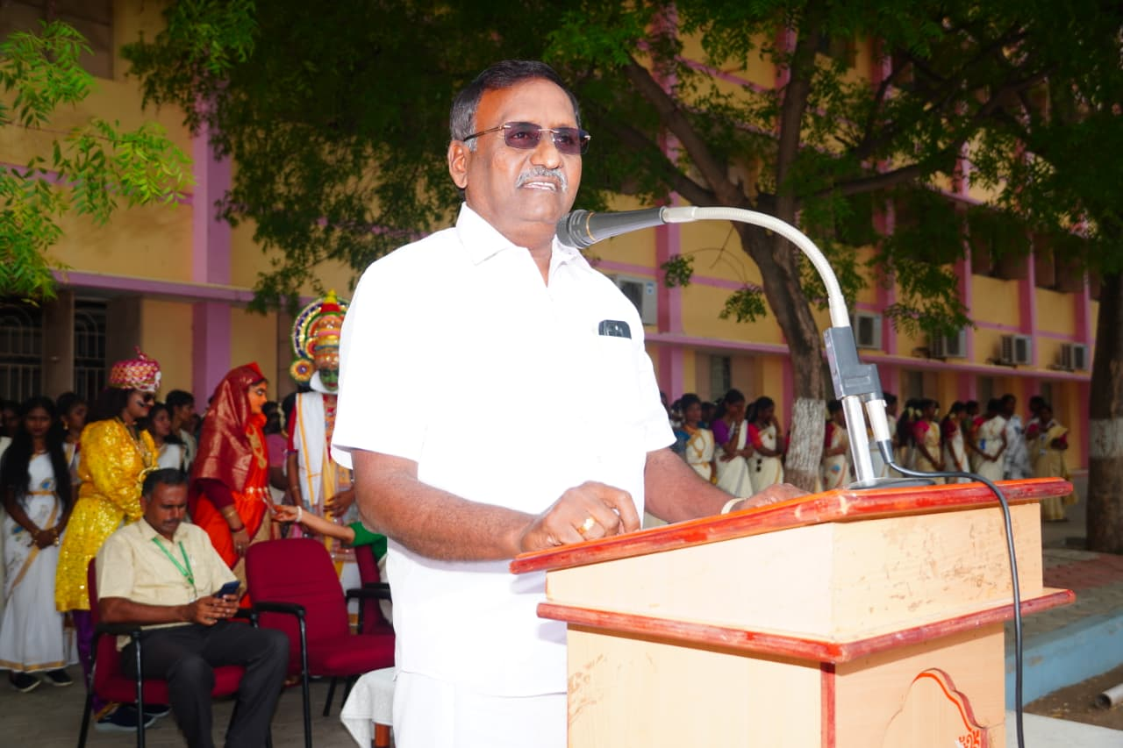
Mr. SRT. R. Selvamani
Treasurer
SRT. R. Selvamani
The growth of an educational institution is not just about buildings and infrastructure. The true, holistic development of a college is possible only through the seamless integration of quality education, student safety and welfare, faculty dedication, research advancement, skill development, and excellent placement opportunities.

In that sense, it is no exaggeration to state that our Bharathiyar Arts and Science College for Women (Autonomous) has attained a distinguished state of excellence.

We have successfully provided all the essential academic and fundamental facilities required by our students. By continuously upgrading our modern classrooms, laboratories, the library, computer and internet infrastructure, and sports facilities to keep pace with the changing times, and by elevating our academic standards, we have cultivated an outstanding learning environment.

The financial resources of the college are utilized with utmost transparency and accountability, strictly prioritizing the educational advancement of our students. Every single resource invested here to serve as a foundation for shaping their future.

Keeping in mind the financial constraints of economically needy students, our college imparts exceptional education impartially and in an accessible manner. My vision for the journey ahead is to see this institution evolve not just as a world-class provider of premier education, but to ultimately rise to the esteemed status of a Deemed-to-be University."

Mr. SRT. R. Selvamani
Treasurer

Principal Dr. D. Rajakumari
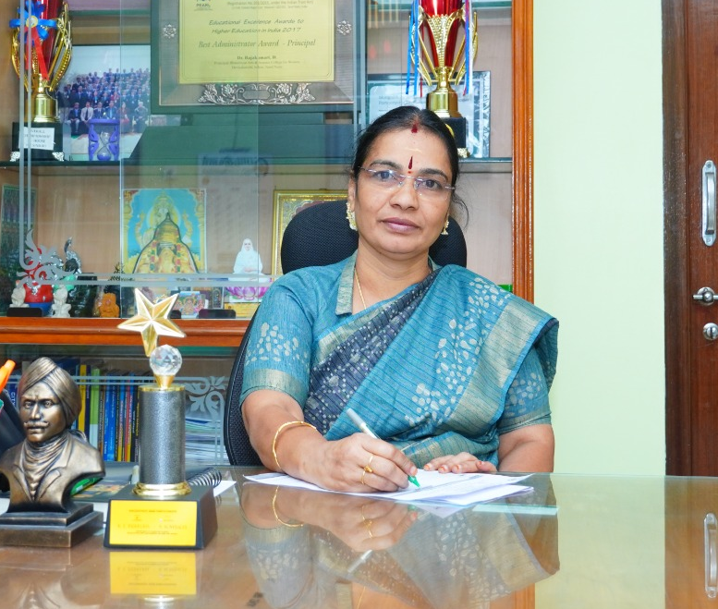
Dr. D. Rajakumari
Principal

"College should not be just a place to offer degrees. Its real purpose should be to develop the knowledge, skills and self-confidence of the students and make them successful personalities in all walks of life.

My vision for the future is that our Bharathiyar Arts and Science College for Women (Autonomous) will continue to be a pioneer in Academic Excellence, Research, Technology, Skill Development, and Employment.

In the future, our students will excel not only in academics but also in various fields including Research, Entrepreneurship, Administration, Media, Law and Social Service. To facilitate this, we are consistently providing updated curricula, skill-based training, technical education, international collaborations, industry MoUs, and robust placement opportunities.

With the firm belief that women’s education is a powerful force that uplifts not just one, but multiple generations, our curriculum has been thoughtfully designed in alignment with the modern education system. It aims to empower every student to act with self-confidence, a sense of responsibility, and social consciousness.

My dream and ultimate goal is for our college to emerge not only as an institution of academic excellence but also as a nurturing space that shapes successful, high-achieving women.
Today's students are tomorrow's guides for society. With the aim of giving wings to their dreams, providing due opportunities for their talents, and shaping capable women who can compete on a global stage, we march forward
"What we envision must be achieved,
And our thoughts must always be noble.
Our dreams must come true,
And they must be realized swiftly."

​My future ambition for our college is to emerge as an outstanding university-level institution, bringing these profound words to life.

Dr. D. Rajakumari
Principal

